Test case execution
- Copy test data to “c:\” It includes following folders
WindowsAzureProject
WindowsAzureProjectErr
WindowsAzureProjectErr1
WAStarterKitForJava.zip
WAUpgrade.zip
- Unzip WAUpgrade.zip on “c:\”
- Open command prompt (Windows Key + R to get Run dialog box and type cmd)
- In command prompt, go to the Project Folder

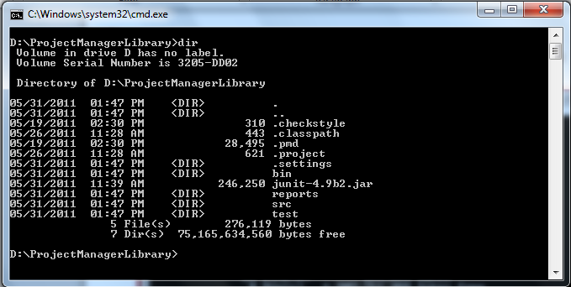

- To execute all test cases run :

java -classpath "D:\ProjectManagerLibrary\bin";"d:\junit-4.9b2.jar" org.junit.runner.JUnitCore com.interopbridges.tools.windowsazure.AllTests

The following screen shot shows output of all test case execution.

